**AAUW - HAMPTON BRANCH**



November 23, 2020

Greetings!

We started the 2019-2020 program year with a hopeful hearts and ideas. Although the corona virus (COVID 19) brought an end to in person meetings and scheduled programs, we were able to accomplish a few items.

The program year began in September with a planning meeting with the emphasis being on preparation for our STEM workshop for girls and weekly STEM programming for grade school girls, and our partnership with the Virginia State Alumni and Barnes and Noble in the National Education Association Read Across America Program. The STEM Workshop for girls in grades 3 to 8 was to be held in April 2020 on the Hampton University Campus with sponsorship by the Engineering and Technology Department and support from their student chapter of the Society for Women Engineers. Last year’s event was a major success, sparked a relationship with the college that we hope to keep, and gave us a new, but old, lesson in teamwork and preparedness.

We were more successful with the weekly hour long hands-on activities branch members held with third grade students at the Newport News Schools Discovery STEM Academy. Girls were given an opportunity to make airplanes and determine the proper weight of paper needed to insure their airplane glide, build paper rocket ships, make pinwheels to demonstrate the movement of air, learn their nine times table using only their fingers, and how to mix ordinary everyday products to create a new product. A part of the learning was to incorporate the history of astronauts, such a Mae Jemison, Sally Ride, and Leland Melvin; reading Hidden Figures, the book about the black women computers at NASA; and, writing pertinent information learned from each activity. Girls were provided a composition book, pens, pencils, and all materials needed by the branch. Every composition book was reviewed to insure that the girls were learning and positive feedback, both verbally and in writing, was given. The notebooks were shared with the STEM coordinator for the school at the end of the marking period and were then given to the girls to keep as a reminder of their experience. The branch was able to continue this activity through the middle of March 2020.

We began Read Across America in October. Once a month branch members gathered at Barnes and Noble to read children’s books. The Barnes and Noble corporate office provided books, supplies, and treats for the event and the bookstore provided space in the children’s section for the readings. The branch, along with the Virginia State Alumni Association (Hampton Chapter), was able to hold the annual Dr. Seuss Birthday Celebration in February prior to the corona virus shut down.

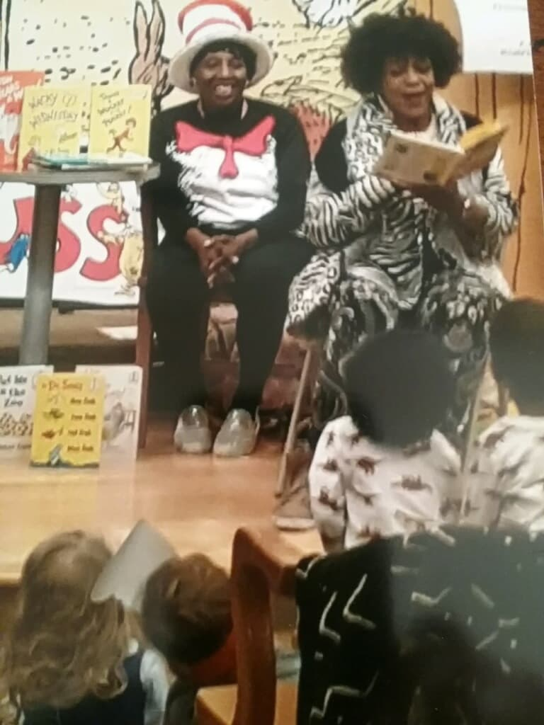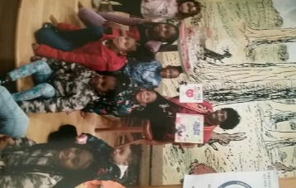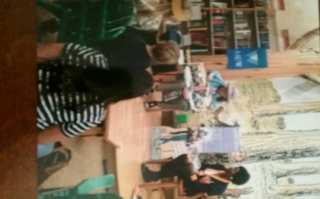

In October 2019, in lieu of a branch meeting, the branch attended the Eastern Regional Meeting at the Deer Run Golf Course in Newport News. Information on becoming a five-star branch was shared. Also, the place and date for the Virginia State Conference, April 17-19, 2020 in Alexandria, Virginia, was shared. Branch member attended the Eastern Regional Meeting in February 2020. A guest speaker spoke about human trafficking in general and specifically in the Tidewater area.

To celebrate the holidays, branch members attended the play, Scrooged, at the Peninsula Little Theatre. The January business meeting, which was held at Schlesinger’s Restaurant, had two guests and one joined. She is now the Public Policy Chair for 2020-2021.

In February, Dr. Natalie S. Robertson, the author of *The Slave Ship Clotilda and the Making of AfricaTown, USA,* was our guess speaker. Her presentation was held at the Charles Taylor Library in Hampton, Virginia. It was open to the public (the flyer announcing her presentation is attached). Her presentation was followed by a lively discussion, and resulted in requests for more presentations in keeping with Black History.

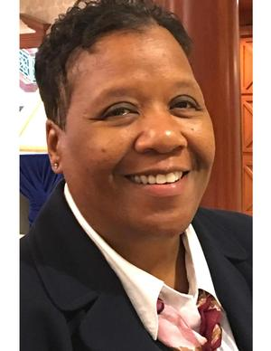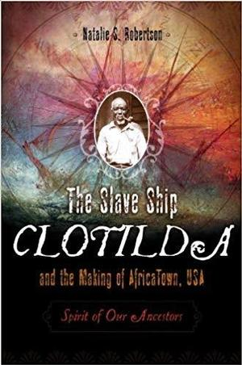

***IN MEMORIAM***

In March 2020, a light went out within our branch. Joan Aaron, a life member of AAUW and a member of the Hampton Branch for more than 60 years passed. Joan was a CPA and served as the Finance Chair/Treasurer until her health failed. She loved opera, and together with other branch members, held season tickets to the Virginia Opera. Speaking French was another of her passion and was tutored weekly in the language. Joan was a thinker and loved contributing to anything that benefitted children. Her light may have gone out but she will always shine brightly within our hearts.

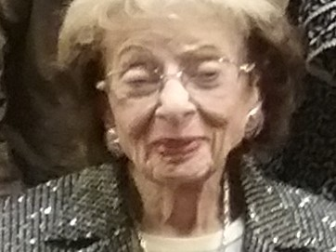

BE WELL, BE SAFE, SOCIAL DISTANCE, AND WASH YOUR HANDS.

Carolyn Stewart

Program Vice President

Hampton Branch